Sahil Deogade

243545

Cloud Assignment 15 March

Q1

In your Github account, create a new repository ‘linux_assignments’

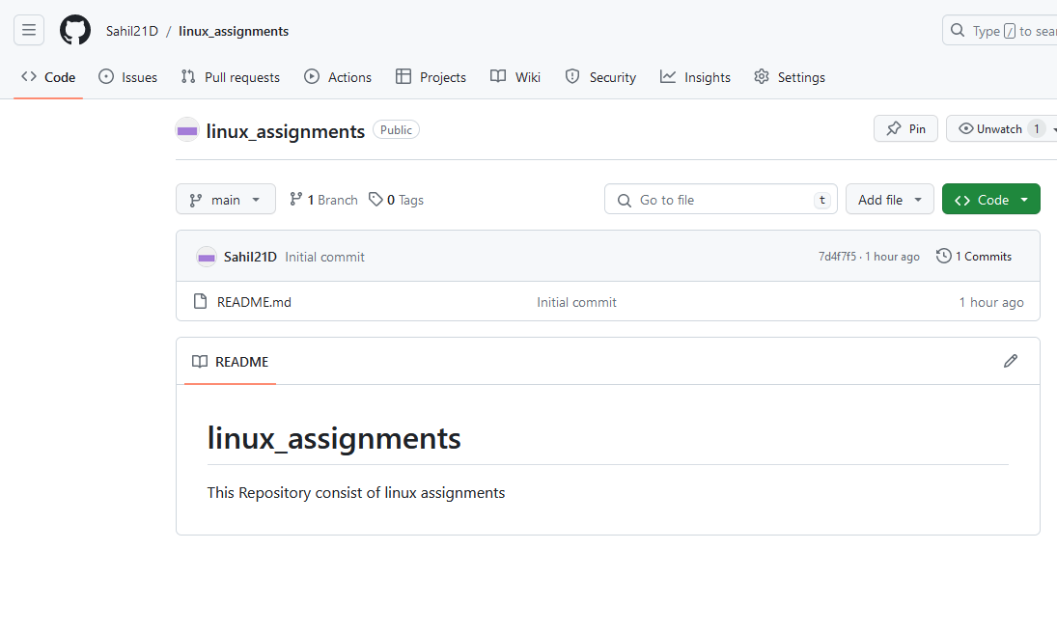

Put all the docx/pdf file solutions for your linux assignments in that folder

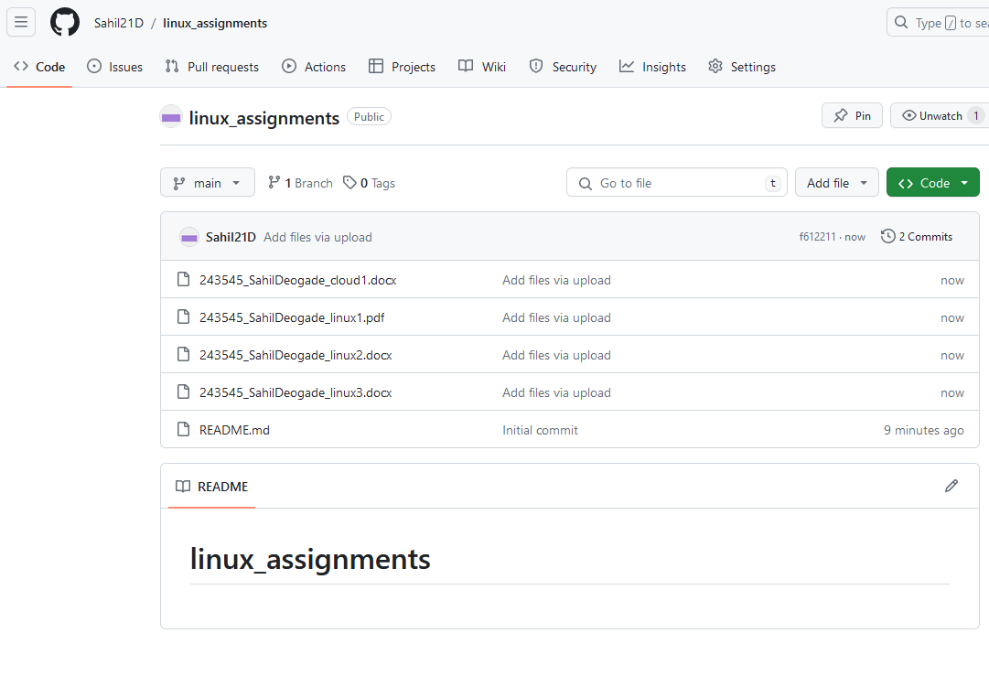

Q2 In your Github account, create a new repository ‘linux_scripts’. Put at least 5 .sh files in that folder.

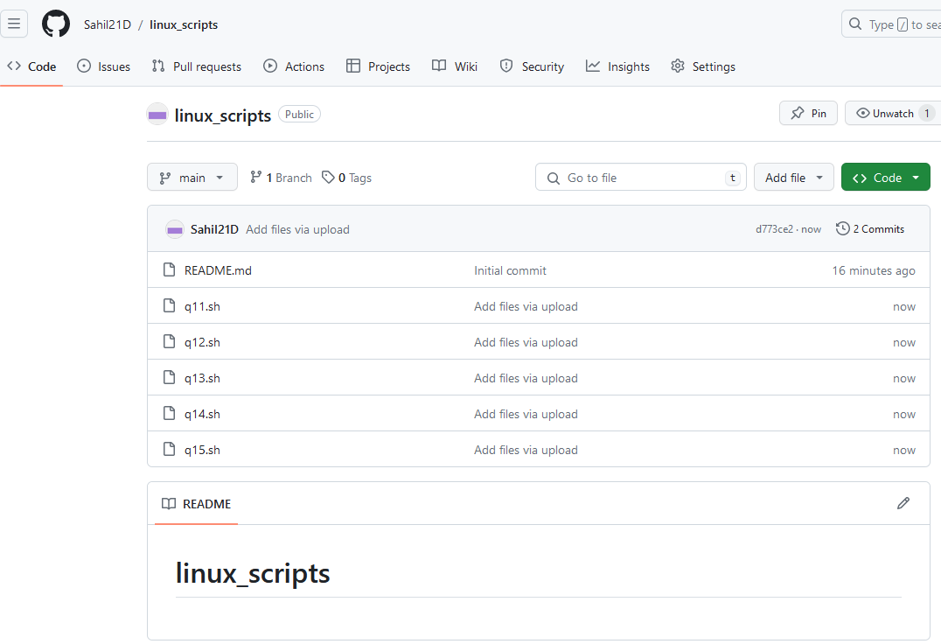

Q.3) Login to AWS console. Create a new instance of EC2 with Ubuntu. On this instance install git

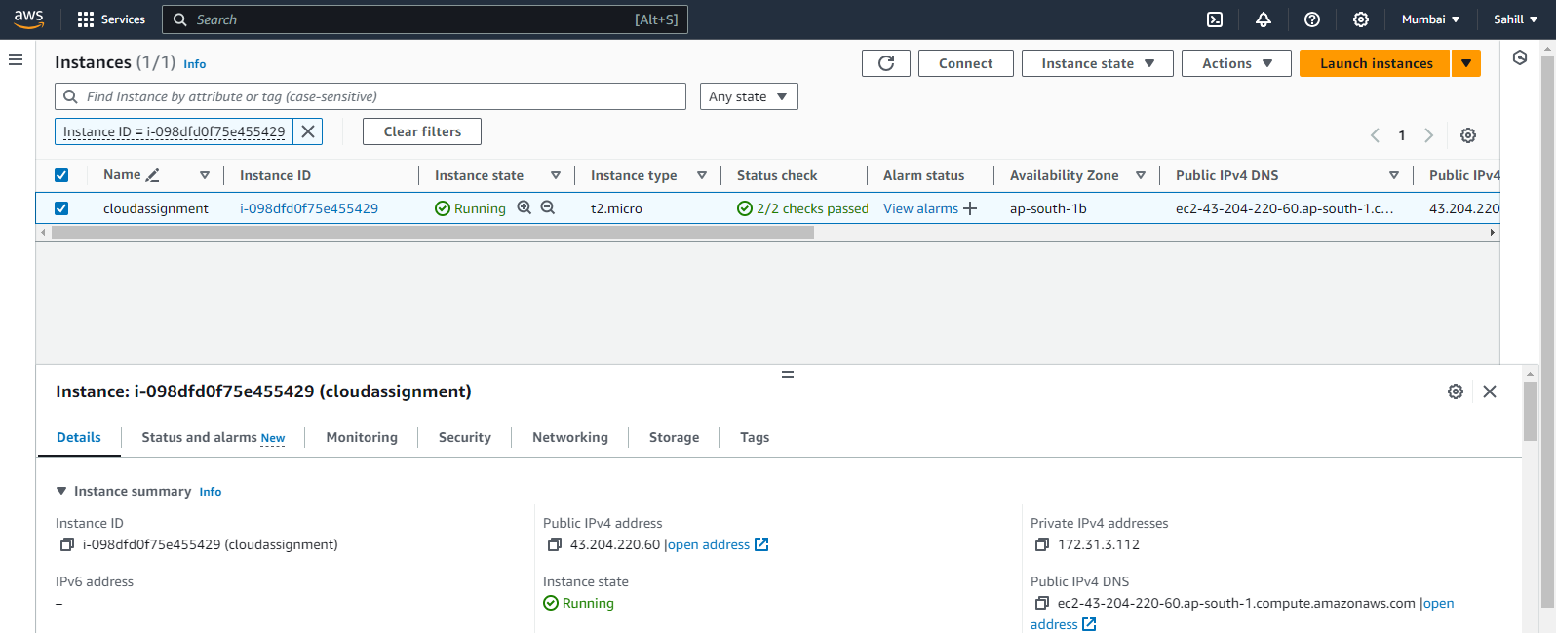

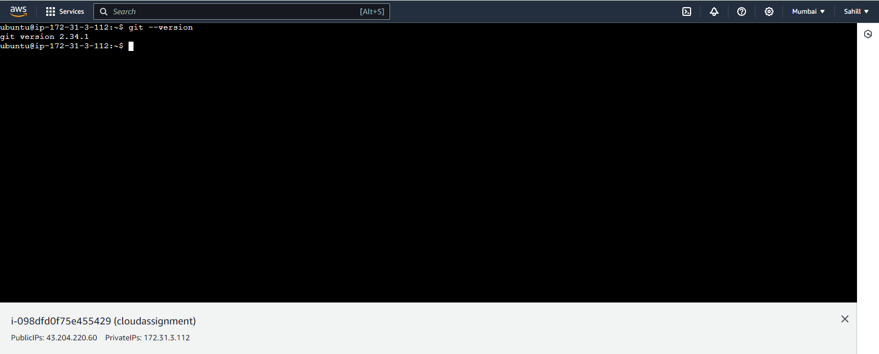

Q4 : After installing git, pull your repository named ‘linux_scripts’. Run scripts inside this repository on ec2 instance. Take screenshots and save them in a docx file.

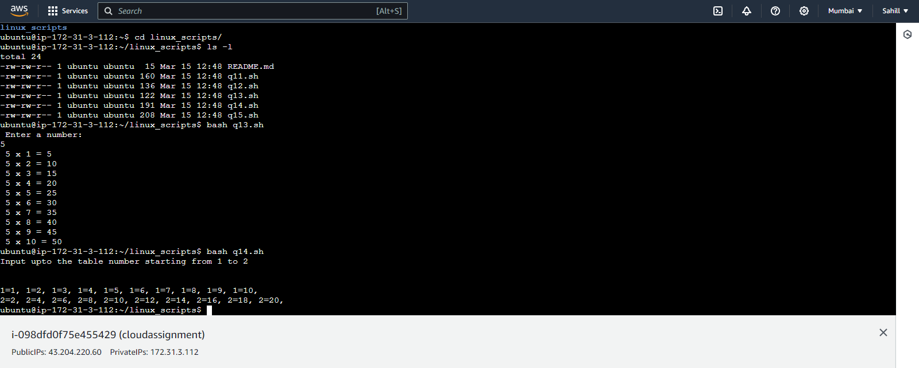

Q5 New repository created

